Metadata Subcommittee
December 8, 2010

Present on Elluminate session:

FAMU Saiyed Ahmad
FCLA Mary Ann O’Daniel
FCGC Catherine Gardiner
FSU Tamara Weatherholt
UCF Kimberly Montgomery, Chair
USF Brian Falato

The Metadata Subcommittee addressed two questions:
- How should foreign language subject headings be treated in the catalog?
- Should the 502 dissertation note use the new formatting subfields or not?

- How Should Foreign Language Subject Headings Be Treated In The Catalog?

Foreign language subject headings come in with copy cataloging, plus some libraries use them on records for foreign language works in addition to LC Subject Headings. The OPAC Subcommittee has said that they would like to retain these subject headings in the records. We decided that these headings should be kept. Libraries could add these headings, but would not be required to do so.

There are two main issues with the use of foreign language subject headings in records: how they are coded and how they display. These headings should have properly coded indicators and/or subfield 7s to indicate the source thesauri of the terms used in the headings.

In Mango, most subject headings display in alphabetical order, grouped under the label “Subjects, general.” Cataloging rules put the most important headings first in a record. But Mango’s merge makes such a rule for display impossible. Mango does separate out two other groups of subject headings: “Subjects, medical” and “Subjects, other.” We would like to ask FCLA to investigate limiting “Subjects, general” to LCSH, “Subjects, medical” to MeSH, and display all other controlled subject headings and genre headings alphabetically under “Subjects, other.”

- Should the 502 dissertation note use the new subfields or not?

After much discussion, the Subcommittee could not find an overwhelming reason either for or against using the new subfields in a 502 note. It was mentioned that we currently have both formatted and unformatted 505 notes co-existing in the catalog. In that case there may be some advantage to formatted subfields that allow the table of contents note to be search by author keyword or by title keyword. However, all 505s are searchable by general keyword, whether formatted or not.

We cannot find a similar advantage for requiring a formatted 502. We doubt that the subfield c containing the degree granting institution data will be brought under authority control. In most cases, the institution that grants the degree will be the only library that will have a record for the thesis or dissertation. The 502 note is currently searchable by keyword.

We propose that libraries may use either formatted or unformatted 502s. There is no need to change 502s in existing records. The new subfields of the 502 should be indexed along with the 502 subfield a.

Recorder: Kimberly Montgomery
Appendix

Example 1

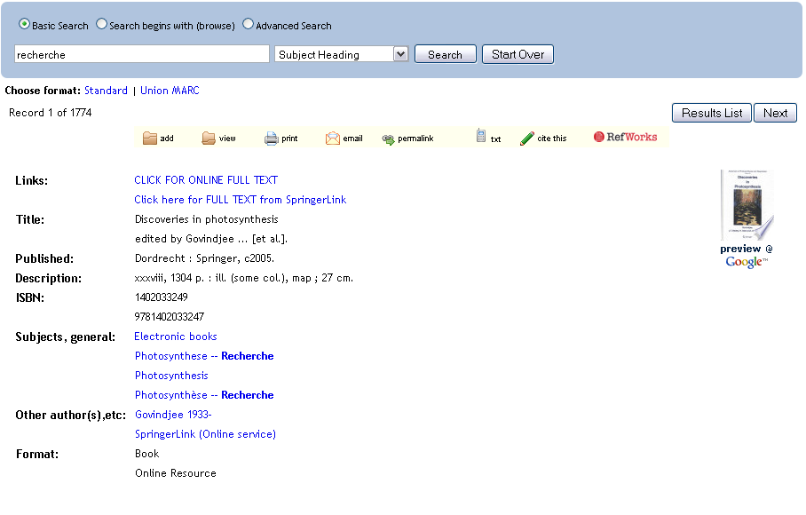

In this case, Subjects, general contains a genre heading, foreign language headings (differing by an accent mark) and one LC subject heading. The display is in alphabetical order. The LC subject heading is in third place.

The proposed display would be (given the merge data):

Subjects, general: Photosynthesis
Subjects, other: Electronic books
Photosynthese -- Recherche
Photosynthèse -- Recherche
Example 2

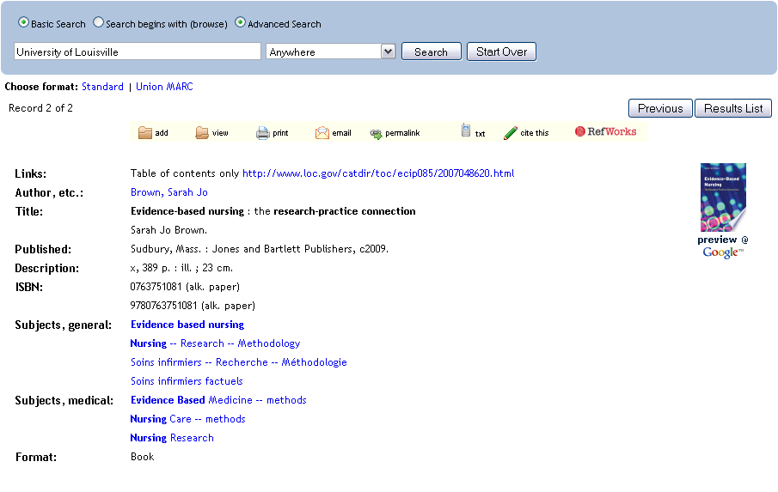

This example shows that medical subject headings are treated separately.

The proposed display would be:

Subjects, general: Evidence based nursing
Nursing -- Research -- Methodology
Subjects, medical: Evidence Based Medicine -- methods
Nursing Care -- methods
Nursing Research
Subjects, other: Soins infirmiers -- Recherche -- Méthodologie
Soins infirmiers factuels

